Job Satisfaction (jobsatisfaction1) variable is acquired by reverse coding the Global Job Satisfaction Job #01 column in the following way: 1 is mapped to 4, 2 to 3, 3 to 2 and 4 to 1.

**Results**

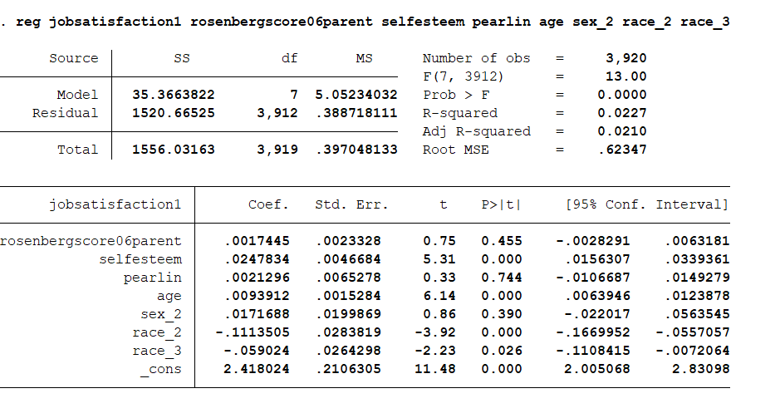

Self-esteem, Age and Race_2 (Black) have significant correlations with Job Satisfaction. The race coefficient can be interpreted like this- compared to base (race_1 which is Hispanic), race_2 people have 0.1114 lower job satisfaction.

The descriptive statistics of the Job Satisfaction column is shown below:  
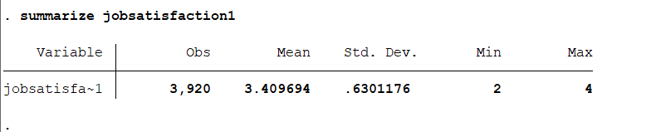

An overall descriptive statistic is shown below  
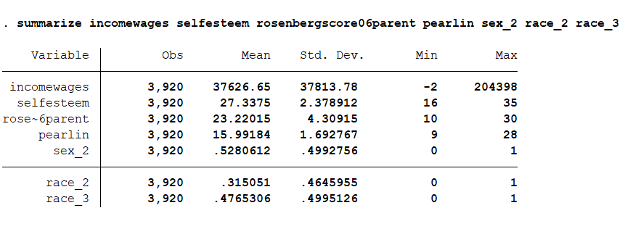

Below is the descriptive statistic for the column Income of the wages+business dataset:

